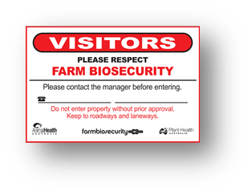
Order Form – Farm Biosecurity Gate Sign

- Please complete all details below
Name

Postal address

Contact details
(Phone/email)
Invoice/Bpay Ref. No | Please enter ‘Gate – your name eg. John smith’

No. of Signs required | Cost per Sign  (incl. postage & GST) | Total amount payable  (incl. postage & GST) | Industry (pls tick)  Animal or Plant
 | $40.00 |  | Animal  Plant

Please note This document will be a tax invoice for GST when you make a payment.
ABN: 86 071 890 956
 | Amount ($)
Complete this order form and send it back via:
- Email: dbarnard@animalhealthaustralia.com.au
- Post: Animal Health Australia, PO BOX 5116 Braddon, ACT 2612.
- Payment options | 200.00
- By Credit Card
Go to: Animal Health Australia’s online Payment Gateway (hosted by Westpac) which takes you to the credit card payment page. Use your name (eg. Gate-B Harris) as the Invoice/Bpay Ref. No.

2. Cheque By Mail
Animal Health Australia
PO BOX 5116
Braddon, ACT 2612
Please make cheques payable to: Animal Health Australia
Make sure to attach cheque to your order form and post to the above address.

For more information please contact Danika Barnard (02) 6203 3904 or email dbarnard@animalhealthaustralia.com.au

