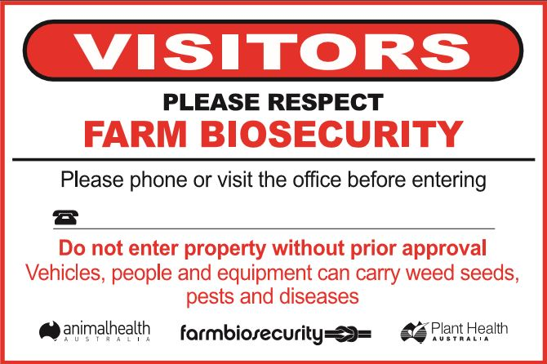
Order Form – Farm Biosecurity Gate Sign

- Please complete all details below
Name

Postal address

Contact details
(Phone/email)

No. of Signs required | Cost per Sign | Total amount payable
 | $40.00
Please note the signs are a total of $40.00. This cost is inclusive of all postage and GST charges.
Please note This document will be a tax invoice for GST when you make a payment.
ABN: 86 071 890 956

Payment: | 200.00
Cheque By Mail
Animal Health Australia
PO BOX 5116
Braddon, ACT 2612
Please make cheques payable to: Animal Health Australia
Make sure to attach cheque to your order form and post to the above address.

For more information please contact Alannah Andreini (02) 6203 3932 or email aandreini@animalhealthaustralia.com.au

